**[6. SL4J Logging Outputs](blob:https://github.com/dd037c8b-569d-42aa-887e-bf77b8d64ab7" \o "6. SL4J Logging exercises.pdf)**

**Exercise 1: Logging Error Messages and Warning Levels**

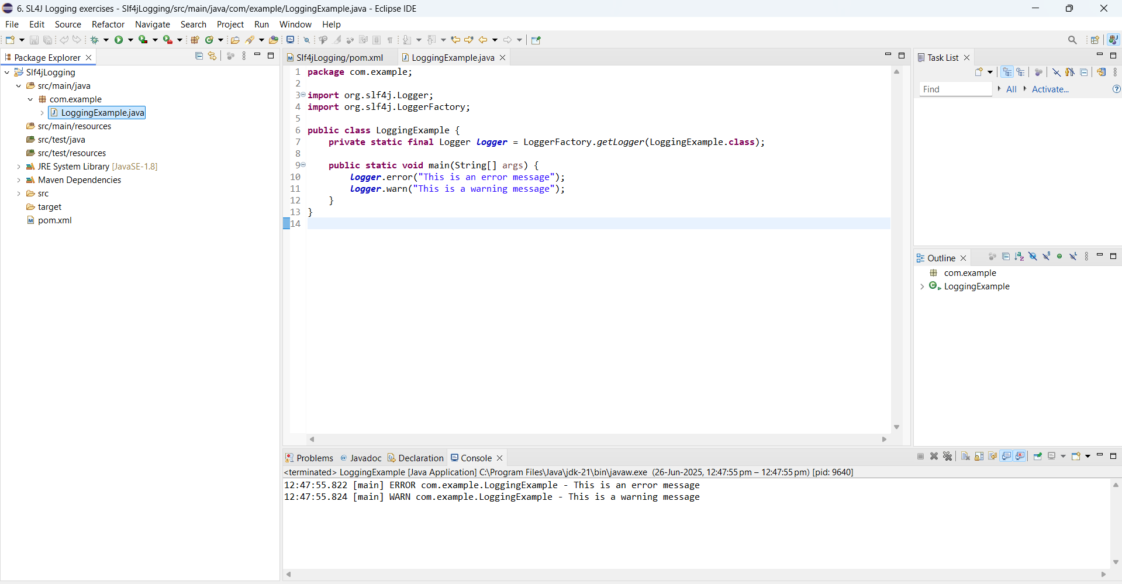

**Exercise 2: Parameterized Logging**

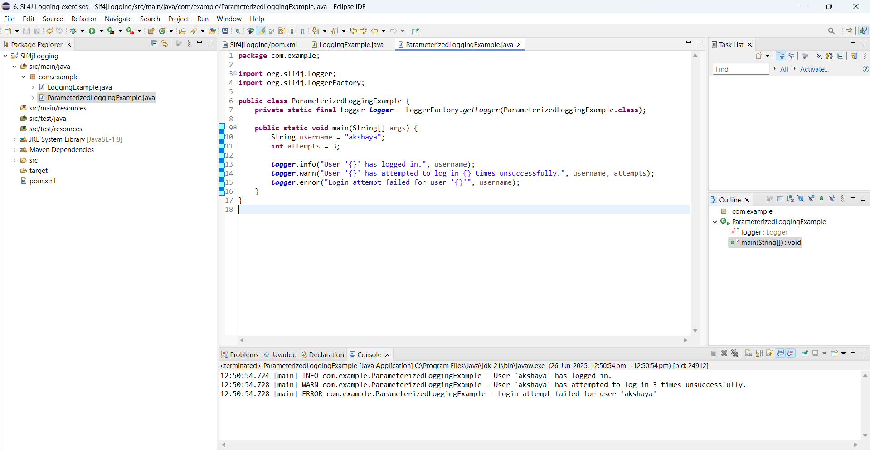

**Exercise 3: Using Different Appenders**

